|  |
| --- |
| **Geophysics Exercise :  Geomagnetic field** |

**Fikrah Elhifzi Harahap**



***January 2022***

1. **Presentation of used data, algorithms, equations**

* **Geographic coordinates of the reference point**

In Here, I am choosing the area of my capital city in Indonesia, which is Jakarta. As you can see the Latitude and Longitude of this area is -6.175394 and 106.827183

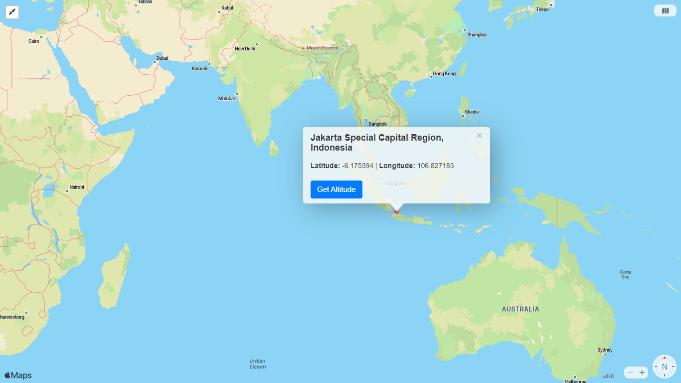

* **Used data**

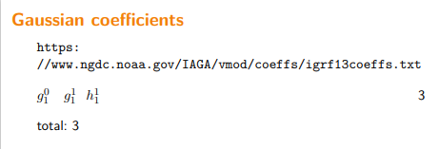

* **Used formulas**

Φ = co_latitude=90-latitude=90-(-6.1753942)= 96.1753942)

Λ=longitude = 106.827183

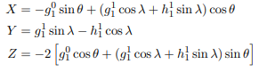

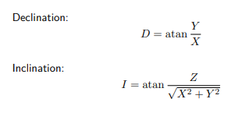

* **Algorithms (Matlab)**

%%

clear

%loading data from igrf13coeffs_data.txt

igrf=importdata('first_dipole_igrf13coeffs.txt');

year=igrf(1,:);

g1_0=igrf(2,:);

g1_1=igrf(3,:);

h1_1=igrf(4,:);

% I have taken the coordiants of Jakarta Special Capital Region, Indonesia

lat=-6.1753942

co_lat=90-lat

lon=106.827183

%compute the magnetic intensity for the point latitude and longitude

for i=1:length(g1_0)

X(i,1)=-g1_0(i)*sin(co_lat*pi/180)+(((g1_1(i)*cos(lon*pi/180))+(h1_1(i)*sin(lon*pi/180)))*cos(co_lat*pi/180))

Y(i,1)=(g1_1(i)*sin(lon*pi/180))-(h1_1(i)*cos(lon*pi/180))

Z(i,1)=-2*((g1_0(i)*cos(co_lat*pi/180))+(((g1_1(i)*cos(lon*pi/180))+(h1_1(i)*sin(lon*pi/180)))*sin(co_lat*pi/180)))

end

%declination

for i=1:length(year)

D(i,1)=atand(Y(i)/X(i))

end

%inclination

for i=1:length(year)

I(i,1)=atand(Z(i)/sqrt((X(i)^2)+(Y(i)^2)))

end

%visualisation of magnetic intensity and declination and the inclination

figure('Name','magnetic intensity plots')

subplot(1,3,1)

plot(year,X);

title(' X = f(Year)')

xlabel(' year ')

ylabel(' X [nanoTesla] ')

grid on

subplot(1,3,2)

plot(year,Y);

title(' Y = f(Year) ')

xlabel(' year ')

ylabel(' Y [nanoTesla] ')

grid on

subplot(1,3,3)

plot(year,Z);

title(' Z = f(Year)')

xlabel(' year ')

ylabel('Z [nanoTesla]')

grid on

figure('Name','declination and inclination plots')

subplot(1,2,1)

plot(year,D)

title(' Declination = f(Year) ')

xlabel(['year'])

ylabel('D [°]')

grid on

subplot(1,2,2)

plot(year,I)

title(' Inclination = f(Year) ')

xlabel('year')

ylabel('I [°]')

grid on

1. **Presentation of the results**

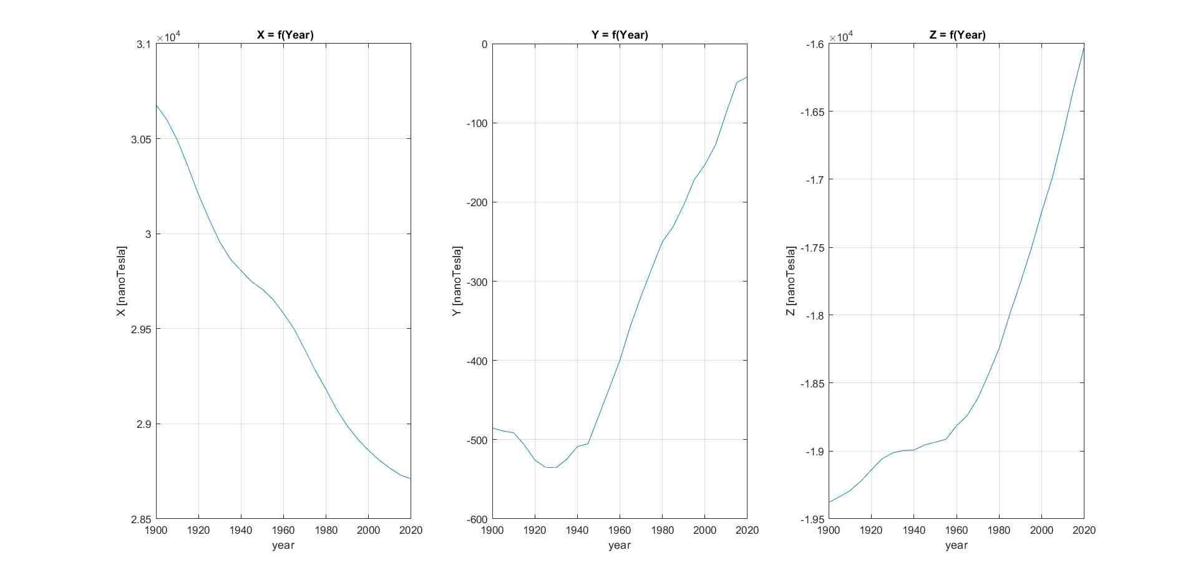

Figure 2: magnetic intensity

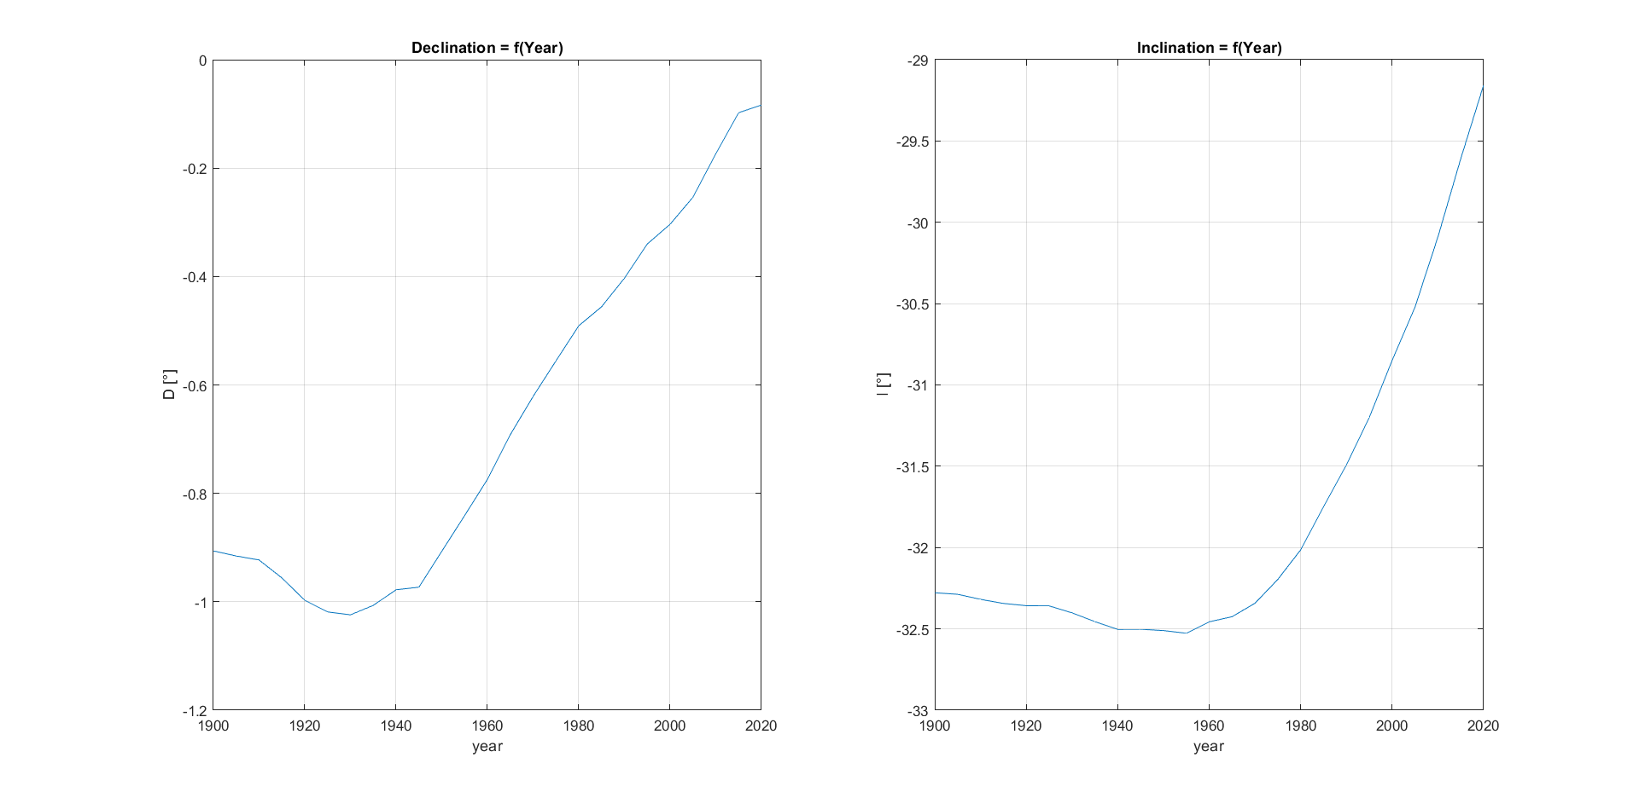

Figure 3: Declination and Inclination

**Conclusion :**

Firstly, in the terms of Magnetic fields we are using units of tesla (T) for measurement. Basically, the Tesla is the largest unit for geophysical observations which nanotesla is smaller unit. One nanotesla is equal with 10-9 tesla. In addition 1 nanotesla is equal with one gamma, a unit originally defined as 10−5 gauss, which is the unit of magnetic field in the centimetre-gram-second system.

As we can see in the table, magnetic intensity is described by the vertical component (Z), and the north (X) and east (Y) components of the horizontal intensity. As you can see in the picture, the magnetic field is increasing in the capital city of Indonesia, except the direction to positive northward (X). In terms of magnetic field, The stronger the magnet, the greater the number of lines of force. Therefore in the case of (X) the number of lines of force is decreasing in the direction positive northward.

In the last two table, basically, declination and inclination are the angle. magnetic declination, defined as the angle between true north (geographic north) and the magnetic north (the horizontal component of the field). D is positive eastward of true North, While magnetic inclination, defined as the angle measured from the horizontal plane to the magnetic field vector; downward is positive. Basically both of these angle tend to increase which means the direction of magnetic field is changing over the years.